**Chapter 10**

**Digital image processing**

**5.1. An Introduction to digital image Processing**

Signal processing is a discipline in electrical engineering and in mathematics that deals with analysis and processing of analogy and digital signals, and deals with storing, filtering, and other operations on signals. These signals include transmission signals, sound or voice signals, image signals, and other signals etc.

Out of all these signals, the field that deals with the type of signals for which the input is an image and the output is also an image is done in image processing. As its name suggests, it deals with the processing of images. It can be further divided into analogy image processing and digital image processing. In the following figure a system has been shown whose input and output both are signals but the input is an analogy signal. And the output is a digital signal. It means our system is actually a conversion system that converts analog signals to digital signals.

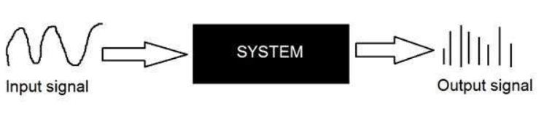

*Figure 1:analog-digital image system*

Since capturing an image from a camera is a physical process. The sunlight is used as a source of energy. A sensor array is used for the acquisition of the image. So when the sunlight falls upon the object, then the amount of light reflected by that object is sensed by the sensors, and a continuous voltage signal is generated by the amount of sensed data. In order to create a digital image, we need to convert this data into a digital form. This involves sampling and quantization. (They are discussed later on). The result of sampling and quantization results in a two dimensional array or matrix of numbers which are nothing but a digital image

The field of digital image processing (DIP) refers to the processing of digital images by means of a digital computer. A digital image is composed of a finite number of elements, each of which has a particular location and values of these elements are referred to as picture elements, image elements, pels and pixels. Digital image processing is a subfield of signals and systems but focuses particularly on images. DIP focuses on developing a computer system that is able to perform processing on an image. The input of that system is a digital image and the system processes that image using efficient algorithms, and gives an image as an output. The most common example is Adobe Photoshop. It is one of the widely used applications for processing digital images.

* In computer science, digital image processing is the use of computer algorithms to perform image processing on digital images.

In the following figure, an image has been captured by a camera and has been sent to a digital system to remove all the other details, and just focus on the water drop by zooming it in such a way that the quality of the image remains the same.

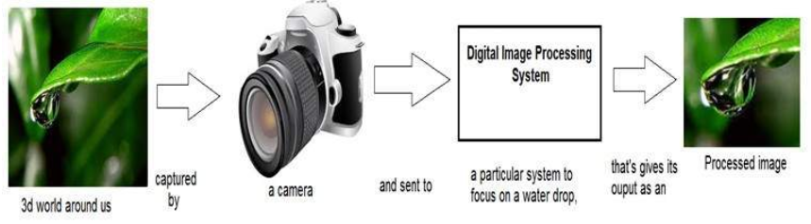

*Figure 2: Example for digital image processing*

**Analog image processing**

* Analog image processing is done on analogy signals. It includes processing on two dimensional analogy signals. In this type of processing, the images are manipulated by electrical means by varying the electrical signal. The common example included is the television image.
* They are formed by complex interaction between light and physical objects.

**Digital image processing**

* Digital image processing deals with developing a digital system that performs operations on a digital image.
* Data is represented in a discrete from using patterns of binary digits that can encode numbers within finite ranges.
* Pixels are point locations with associated sample values usually of light intensities/colors, transparency and other control information.
* Pixels can be created by digitizing images using sample based "painting" programs.
* Once an image is defined as a pixel-array, it can be manipulated.
* As a subcategory or field of digital signal processing, digital image processing has many advantages over analog image processing.
* It allows a much wider range of algorithms to be applied to the input data and can avoid problems such as the build-up of noise and signal distortion during processing.
* Since images are defined over two dimensions, digital image processing may be modelled in the form of multidimensional systems

**Overlapping fields:**

* ***Machine vision or computer vision*** deals with developing a system in which the input is an image and the output is some information. For example: Developing a system that scans the human face.



*Figure 3: Human face recognition example*

* ***Computer graphics*** deal with the formation of images from object models, rather than the image captured by some device. For example: Object rendering. Generating an image from an object model.

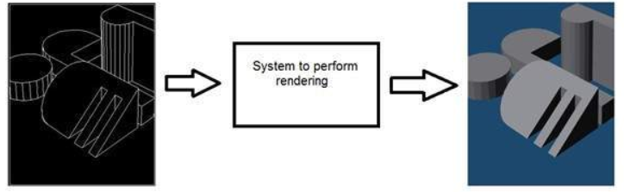

*Figure 4: Rendering example*

* ***Artificial intelligence*** is more or less the study of putting human intelligence into machines. Artificial intelligence has many applications in image processing. For example: developing computer aided diagnosis systems that help doctors in interpreting images of X-ray, MRI e.t.c and then highlighting conspicuous sections to be examined by the doctor.

**Image processing** involves ***changing the nature of an image in order* to** either:

1. Improve its pictorial information for human interpretation.
2. Render it more suitable for autonomous machine perception.

**Improve its pictorial information for human interpretation examples:**

* **Enhancing the edges** of an image to make it appear sharper
* Sharpening edges is a vital component of printing
* **Removing “noise”** from an image
* Noise is a very common problem in data transmission
* **Removing motion blur** from an image
* Motion blur occur in photographs of fast moving objects

**Render it more suitable for autonomous machine perception examples:**

* **Obtaining the edges of an image**
* necessary for the measurement of objects in an image
* **Removing detail from an image**
* we may not be interested in all the detail in an image

(Discard unnecessary details).

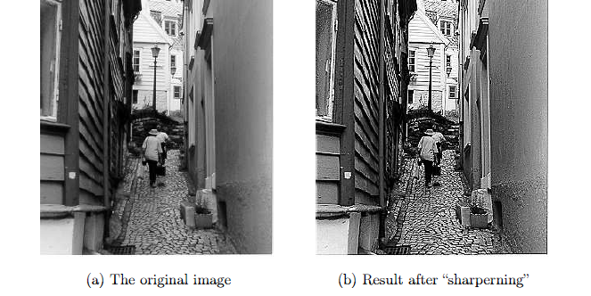

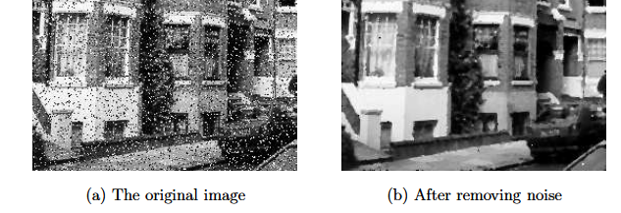

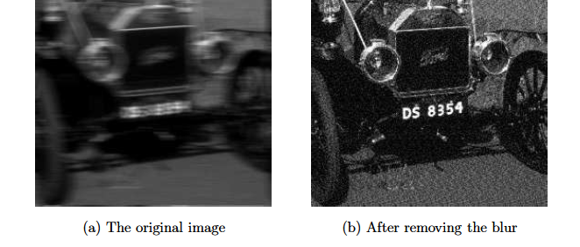

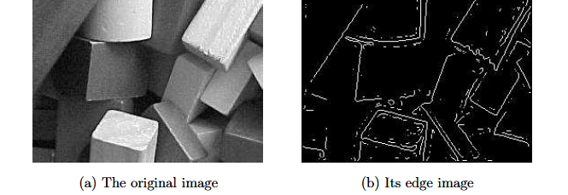

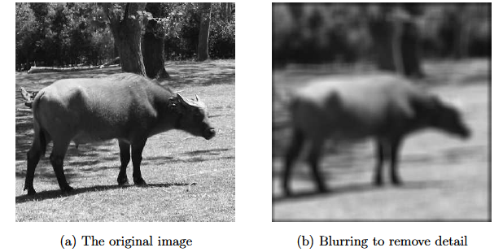

*Figure 5: Image enhancement*

**5.2. Image types**

**What is an Image?**

* Array of picture elements or pixels produced by the graphics system.
* Image is composed of a finite number of elements, each of which has a particular location and value called picture elements, image elements and pixels.
* An image is nothing more than a two dimensional signal. It is defined by the mathematical function f(x,y) where x and y are the two coordinates horizontally and vertically
* The value of f(x,y) at any point gives the pixel value at that point of an image.

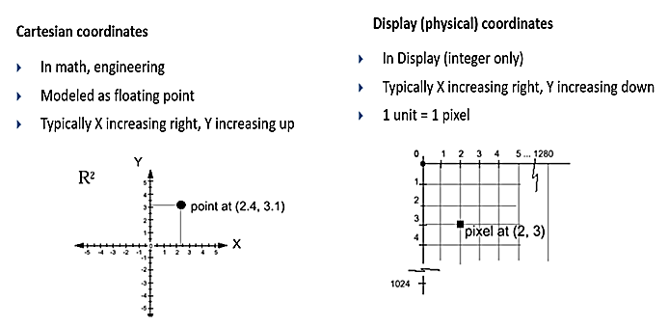

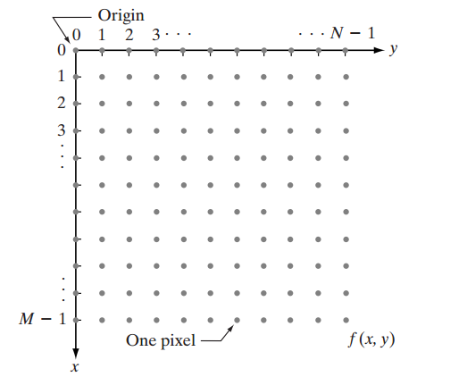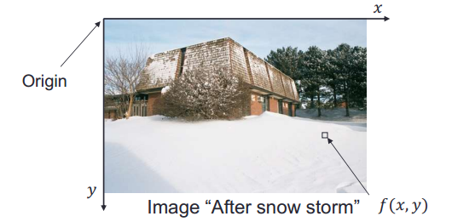

**Coordinate convention used to represent digital images**

We will use two principal ways to represent digital images. Assume that an image f (x, y) is sampled so that the resulting digital image has M rows and N columns. The values of the coordinates (x, y) now become discrete quantities. For notational clarity and convenience, we shall use integer values for these discrete coordinates. Thus, the values of the coordinates at the origin are (x, y) = (0, 0). The next coordinate values along the first row of the image are represented as (x, y) = (0, 1). It is important to keep in mind that the notation (0, 1) is used to signify the second sample along the first row. It does not mean that these are the actual values of physical coordinates when the image was sampled. Figure 1 shows the coordinate convention used.

The notation introduced in the preceding paragraph allows us to write the complete M*N digital image in the following compact matrix form:

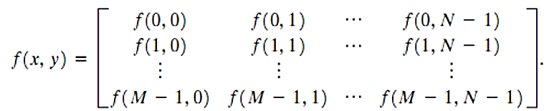

The right side of this equation is by definition a digital image. Each element of this matrix array is called an image element, picture element, pixel, or pel

* **Image resolution:**
* The number of pixels in the horizontal direction times the number of pixels in the vertical dimension in an image.
* The number of pixels in an image.

**Higher resolution always yields better quality but more in size.**

* **Depth (precision):**
* The number of bits that are used for each pixel and determines properties such as colors can be represented on a given system.
* The more bits per pixel, the more colors in the image, the more size of an image, the higher image quality.
* **Aspect ratio:**
* The ratio of the width to the height of an image.

-TV 4: 3

-HDTV 16: 9

* Never change the aspect ratio of a photo – it distorts the image

**Number of color in an image = 2n**

**- where n represents image depth.**

**Examples:**

|  |  |  |
| --- | --- | --- |
| No. of bits (depth) | No. of colors | Image type |
| 1-bit deep | Only two colors (black and white) | Binary (monochrome) |
| 8-bit deep | 28 = 256 colors | Grey - indexed |
| 24-bit deep | 224 colors | True color image |
| 32-bit deep | 232 colors | High dynamic range (HDR) |

* **Types of digital images … (four basic types of images)**



**Binary (monochrome image):**

* Binary image or black and white image
* Each pixel contains one bit: [1 represent white, 0 represents black]
* Monochrome 1-bit images can be satisfactory for pictures containing only simple graphics and text.
* Bit depth 1 bit/pixel
* Image size = width x height x #ofbitesPerPixel = xxxxx bits

= image resolution x color depth

**Example:**

Suppose you have 640×480 monochrome image … what is the **size** of the image

Suppose you have 640×480 monochrome image … what is the **size** of the image

Size = 640 × 480 × 1 bit = 307,200 bits= 38,400 bytes

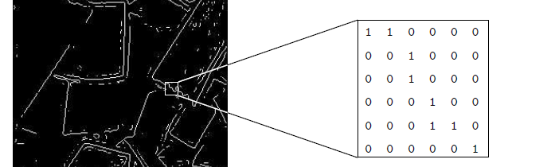

**8-bit gray level image**

* Each pixel is represented by a single byte.
* It is visualized as a shade of gray denoted a gray-scale value or gray-level value ranging from black (0) to white (255).
* Bit depth 8 bits/pixel
* used in medicine (X-rays)

**Example:**

* Suppose you have a 640×480 gray scale image … What is the size of the image?

$921.6 kbyte. without any compression$

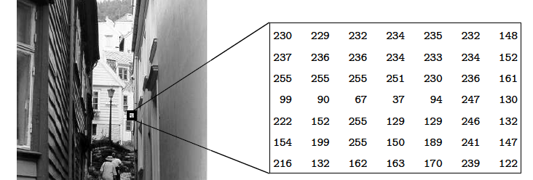

**24-bit color image (Color Image)**

* Each pixel contains a vector representing red, green and blue components.
  + Each pixel is represented by **3-byte**.
* Bit depth 24 bits/pixel
* Provide a method of representing and storing graphical image information in RGB color space where a very large number of colors can be displayed.
  + Supports a total of **16,777,216 possible colors**.

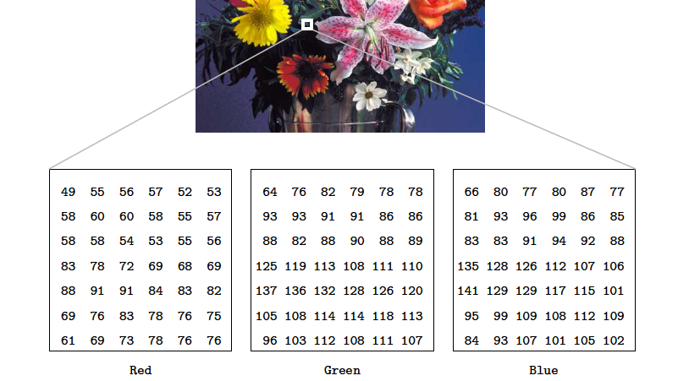

**32-bit image:**

* Many 24-bit color images are actually stored as 32-bit images.
  + **Extra byte** used to store some special effect information **(e.g., transparency)**.

**8-bit color image (Indexed color image/ 256 color/ LUT):**

* Use 8 bits of color information in producing a screen image.
* Graphics systems had frame buffers that were limited in depth.
* Bit depth 🡪8 bits/pixel
* Use the concept of a lookup table to store color information.
* The image does not store the color, but instead an index which points to the real color stored into a table of colors.

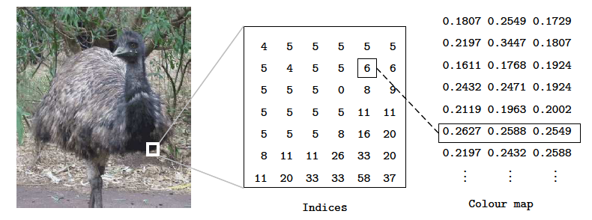

**- Suppose that frame buffer has k bits per pixel 🡪 index is an integer between 0 and 2k-1**

**-Size of LUT = 2k x 3m**

**where k 🡪 depth**

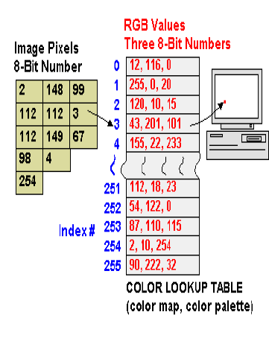

**Example:**

Suppose you have 640×480 indexed image … what is the size of the image?

$307,200 bytes.$

**Example:**

Suppose that you have a 1024 x 768 9-bit image.

* + Calculate the size of the image.
  + Determine number of color levels available.
  + Find Aspect ratio.

**5.3 Conversion of analogy to digital signals**

Since there are a lot of concepts related to this analogy to digital conversion and vice-versa. We will only discuss those which are related to digital image processing. There are two main concepts that are involved in the conversion.

* Sampling
* Quantization

### **Sampling**

Sampling as its name suggests can be defined as take samples. Take samples of a digital signal over the x axis. Sampling is done on an independent variable. In case of this mathematical equation:

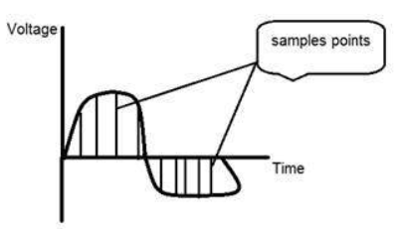

Sampling is done on the x variable. We can also say that the conversion of the x axis (infinite values) to digital is done under sampling. Sampling is further divided into up sampling and downsampling. If the range of values on x-axis are less, then we will increase the sample of values. This is known as up sampling and its vice versa is known as down sampling.

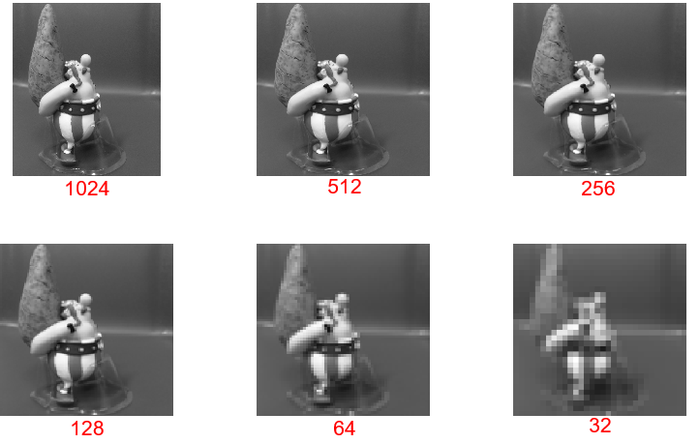

### **Quantization**

Quantization as its name suggests can be defined as dividing into quanta (partitions). Quantization is done on dependent variables. It is opposite to sampling.

In case of this mathematical equation y = sin(x)

Quantization is done on the Y variable. It is done on the y axis. The conversion of y axis infinite values to 1, 0, -1 (or any other level) is known as Quantization.

The quantization of a signal has been shown in the figure.

### **Why do we need to convert an analog signal to digital signal?**

The first and obvious reason is that digital image processing deals with digital images, that are digital signals. So whenever the image is captured, it is converted into digital format and then it is processed.

The second and important reason is, that in order to perform operations on an analog signal with a digital computer, you have to store that analog signal in the computer. And in order to store an analog signal, infinite memory is required to store it. And since that’s not possible, that's why we convert that signal into digital format and then store it in a digital computer and then perform operations on it.

**5.4. Applications of Digital Image Processing**

Some of the major fields in which digital image processing is widely used are mentioned below

* Image sharpening and restoration
* Medical field
* Gamma ray imaging, PET scan, X Ray Imaging, Medical CT, UV imaging
* Remote sensing
* Transmission and encoding
* Machine/Robot vision
* Color processing
* Pattern recognition
* In pattern recognition, image processing is used for identifying the objects in an image and then machine learning is used to train the system for the change in pattern. Pattern recognition is used in computer aided diagnosis, recognition of handwriting, recognition of images e.t.c
* Video processing

A video is nothing but just the very fast movement of pictures. The quality of the video depends on the number of frames/pictures per minute and the quality of each frame being used. Video processing involves noise reduction, detail enhancement, motion detection, frame rate conversion, aspect ratio conversion, color space conversion e.t.c.

* Microscopic Imaging
* Agriculture
* Satellite views of land, to determine how much land is being used for different purposes, or to investigate the suitability of different regions for different crops,
* inspection of fruit and vegetables _ distinguishing good and fresh produce from old
* Industry
* Automatic inspection of items on a production line,
* Inspection of paper samples.
* Law enforcement
* Fingerprint analysis
* Sharpening or de-blurring of speed-camera images

**Image sharpening and restoration**

Image sharpening and restoration refers here to process images that have been captured from the modern camera to make them a better image or to manipulate those images in a way to achieve desired results. It refers to doing what Photoshop usually does.

This includes Zooming, blurring, sharpening, grayscale to color conversion, detecting edges and vice versa, Image retrieval and Image recognition. The common examples are:

|  |  |
| --- | --- |
| **Original image** |  |
| **The zoomed image** |  |
| **Blurry image** |  |
| **Sharp image** |  |
| **Edges** |  |

**The following figure shows the DIP applications**

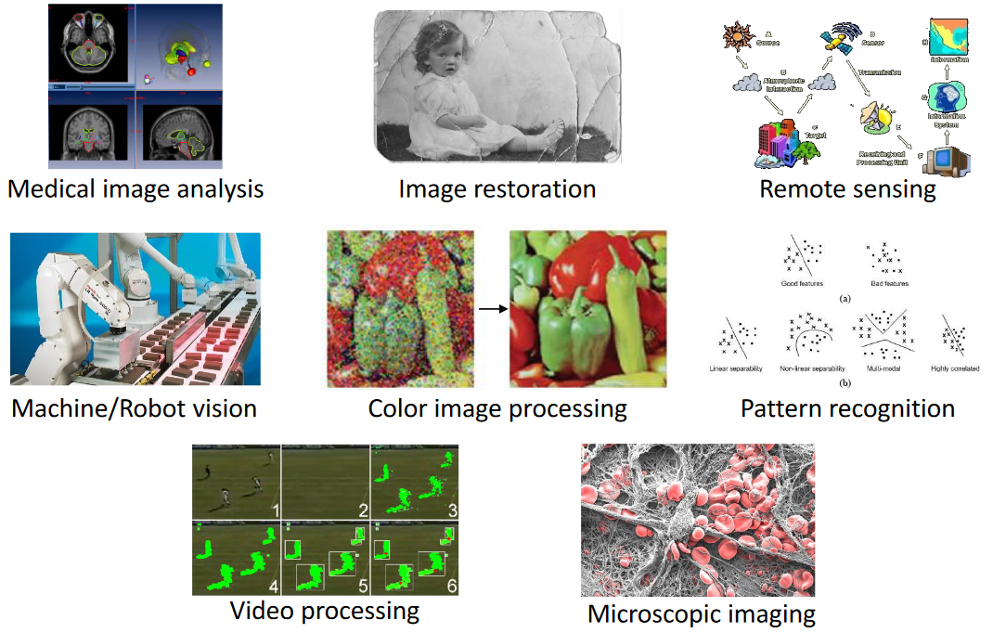

**5.5 Key stages in Digital Image Processing**

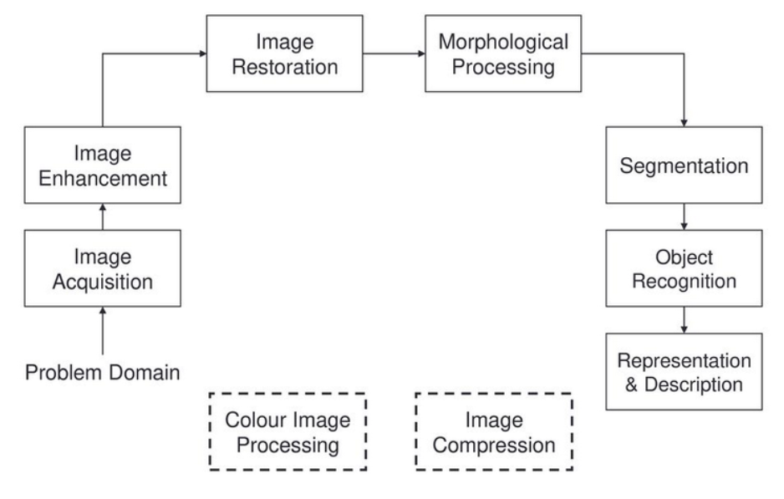

**Image acquisition** is the first process. Note that acquisition could be as simple as being given an image that is already in digital form. Generally, the image acquisition stage involves pre-processing, such as scaling.

**Image enhancement** is among the simplest and most appealing areas of digital image processing. Basically, the idea behind enhancement techniques is to bring out detail that is obscured, or simply to highlight certain features of interest in an image. A familiar example of enhancement is when we increase the contrast of an image because ―it looks better. It is important to keep in mind that enhancement is a very subjective area of image processing.

**Image restoration** is an area that also deals with improving the appearance of an image. However, unlike enhancement, which is subjective, image restoration is objective, in the sense that restoration techniques tend to be based on mathematical or probabilistic models of image degradation. Enhancement, on the other hand, is based on human subjective preferences regarding what constitutes a ― good enhancement result.  
**Color image processing** is an area that has been gaining in importance because of the significant increase in the use of digital images over the Internet. Wavelets are the foundation for representing images in various degrees of resolution.

**Compression**, as the name implies, deals with techniques for reducing the storage required to save an image, or the bandwidth required to transmit it. Although storage technology has improved significantly over the past decade, the same cannot be said for transmission capacity. This is true particularly in uses of the Internet, which are characterized by significant pictorial content. Image compression is familiar (perhaps inadvertently) to most users of computers in the form of image file extensions, such as the jpg file extension used in the JPEG (Joint Photographic Experts Group) image compression standard.

**Morphological processing** deals with tools for extracting image components that are useful in the representation and description of shape.

**Segmentation** procedures partition an image into its constituent parts or objects. In general, autonomous segmentation is one of the most difficult tasks in digital image processing. A rugged segmentation procedure brings the process a long way toward a successful solution of imaging problems that require objects to be identified individually. On the other hand, weak or erratic segmentation algorithms almost always guarantee eventual failure. In general, the more accurate the segmentation, the more likely recognition is to succeed.

**5.6 Components of an Image Processing System:**

Figure 3 shows the basic components comprising a typical general-purpose system used for digital image processing. The function of each component is discussed in the following paragraphs, starting with image sensing. With reference to sensing, two elements are required to acquire digital images. The first is a physical device that is sensitive to the energy radiated by the object we wish to image. The second, called a digitizer, is a device for converting the output of the physical sensing device into digital form. For instance, in a digital video camera, the sensors produce an electrical output proportional to light intensity. The digitizer converts these outputs to digital data.Specialized image processing hardware usually consists of the digitizer just mentioned, plus  
hardware that performs other primitive operations, such as an arithmetic logic unit (ALU), which performs arithmetic and logical operations in parallel on entire images.

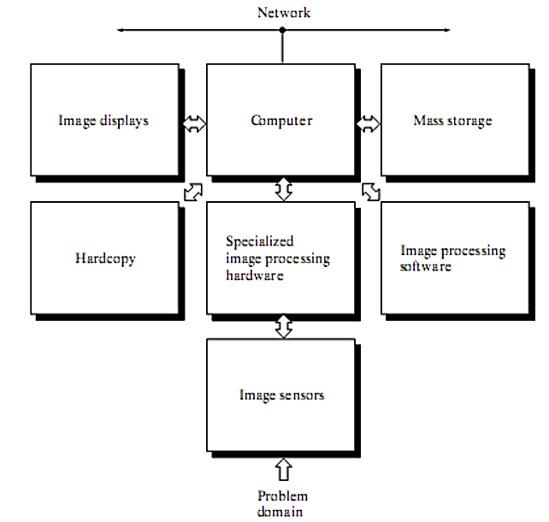

**Components of a general purpose Image Processing System**

The computer in an image processing system is a general-purpose computer and can range from a PC to a supercomputer. In dedicated applications, sometimes specially designed computers are used to achieve a required level of performance, but our interest here is on general purpose image processing systems. In these systems, almost any well-equipped PC-type machine is suitable for offline image processing tasks. Software for image processing consists of specialized modules that perform specific tasks. A well-designed package also includes the capability for the user to write code that, as a minimum, utilizes the specialized modules. More sophisticated software packages allow the integration of those modules and general-purpose software commands from at least one computer language.

Mass storage capability is a must in image processing applications. An image of size 1024*1024 pixels, in which the intensity of each pixel is an 8-bit quantity, requires one megabyte of storage space if the image is not compressed. When dealing with thousands, or even millions, of images, providing adequate storage in an image processing system can be a challenge. Digital storage for image processing applications falls into three principal categories: (1) short-term storage for use during processing, (2) on-line storage for relatively fast recall, and (3) archival storage, characterized by infrequent access. Storage is measured in bytes (eight bits), Kbytes (one thousand bytes), Mbytes (one million bytes), Gbytes (meaning giga, or one billion, bytes), and Tbytes (meaning tera, or one trillion, bytes).

Image displays in use today are mainly color (preferably flat screen) TV monitors. Monitors are driven by the outputs of image and graphics display cards that are an integral part of the computer system. Seldom are there requirements for image display applications that cannot be met by display cards available commercially as part of the computer system.

Hardcopy devices for recording images include laser printers, film cameras, heat-sensitive devices, inkjet units, and digital units, such as optical and CD-ROM disks. Film provides the highest possible resolution, but paper is the obvious medium of choice for written material.

Networking is almost a default function in any computer system in use today. Because of the large amount of data inherent in image processing applications, the key consideration in image transmission is bandwidth

**5.7 Tasks of image processing:**

Digital image processing allows the use of much more complex algorithms, and can offer both more sophisticated performance at simple tasks, and the implementation of methods which would be impossible by analogy means.

**Digital image processing is the only practical technology for:**

* + Classification
  + Feature Extraction
  + Pattern Recognition
  + Projection

**Classification**

The problem of identifying to which of a set of categories a new observation belongs, on the basis of a training set of data containing observations (or instances) whose category membership is known.

**Examples:**

* Assigning a given email to the **"spam"** or **"non-spam" class**
* Assigning **a diagnosis to a given patient based on observed** characteristics of the patient.

**Classification is an example of pattern recognition**

* In the terminology of machine learning, classification is considered an instance of supervised learning.
* **Supervised learning**: Learning where a training set of correctly identified observations is available.
* **Unsupervised procedure (clustering):** involves grouping data into categories based on **some measure of inherent similarity or distance.**

**Feature Extraction**

* In machine learning, pattern recognition and in image processing, feature extraction starts from an initial set of measured data and builds derived values (features) intended to be informative and non-redundant, facilitating the subsequent learning and generalization steps, and in some cases leading to better human interpretations.
* Feature extraction is a dimensionality reduction process, where an initial set of raw variables is reduced to more manageable groups (features) for processing, while still accurately and completely describing the original data set.
* When the input data to an algorithm is too large to be processed and it is suspected to be redundant, then it can be transformed into a reduced set of features (also named a feature vector).

**Feature selection:**

* Determining a subset of the initial features is called feature selection.
* The selected features are expected to contain the relevant information from the input data, so that the desired task can be performed by using this reduced representation instead of the complete initial data.

**Pattern Recognition**

* The field of pattern recognition is concerned with the automatic discovery of regularities in data through the use of computer algorithms and with the use of these regularities to take actions such as classifying the data into different categories

**Projection**

* 3D projection is any method of mapping three-dimensional points to a two-dimensional plane.
* The use of this type of projection is widespread, especially in computer graphics, engineering and drafting.

**Image Noise**

* Image noise is random variation of brightness or color information in images, and is usually an aspect of electronic noise.
* It can be produced by the sensor and circuitry of a scanner or digital camera.
* Image noise is an undesirable by-product of image capture that obscures the desired information.

**Image restoration Vs. image enhancement:**

* Image enhancement is designed to emphasize features of the image that make the image more pleasing to the observer, but not necessarily to produce realistic data from a scientific point of view

**Pixilation:**

* Pixilation is caused by displaying a bitmap or a section of a bitmap at such a large size that individual pixels, small single-colored square display elements that comprise the bitmap, are visible.
  + - Such an image is **said to be pixelated**.
* Early graphical applications such as video games ran at very low resolutions with a small number of colors, resulting in easily visible pixels.
* When the number of available colors increased to 256, it was possible to employ anti-aliasing to smooth the appearance of low-resolution objects, not eliminating pixilation but making it less jarring to the eye.
* Higher resolutions would soon make this type of pixilation all but invisible on the screen, but pixilation is still visible if a low-resolution image is printed on paper.

**Image Editing:**

* Image editing encompasses the processes of altering images, whether they are digital photographs, traditional photo-chemical photographs, or illustrations.
* Traditional analogy image editing is known as photo retouching.
* Graphic software programs grouped into vector graphics editors, raster graphics editors, and 3D modellers
* Graphic software programs are the primary tools with which a user may manipulate, enhance, and transform images.
* Many image editing programs are also used to render or create computer art from scratch.

**Basics of Image Editing**

* Raster images are stored in a computer in the form of a grid of picture elements, or pixels.
* These pixels contain the **image’s color and brightness information**.
* Image editors can change the pixels to enhance the image in many ways.
  + The pixels can be changed as a **group**, or **individually**, by the **sophisticated algorithms within the image editors.**

*It is easier to rasterize a vector image than to vectorise a raster image.*

* Vector images can be modified more easily, because they contain descriptions of the shapes for easy rearrangement.

Also Scalable, being rasterizable at any resolution.

**Automatic Image Enhancement**

* Camera or computer image editing programs offer basic automatic image enhancement features that correct color hue and brightness imbalances and other image editing features, such as red eye removal, sharpness adjustments, zoom features and automatic cropping.
* Called automatic because generally they happen without user interaction or are offered with one click of a button or mouse button or by selecting an option from a menu.
* Some automatic editing features offer a combination of editing actions with little or no user interaction**.**

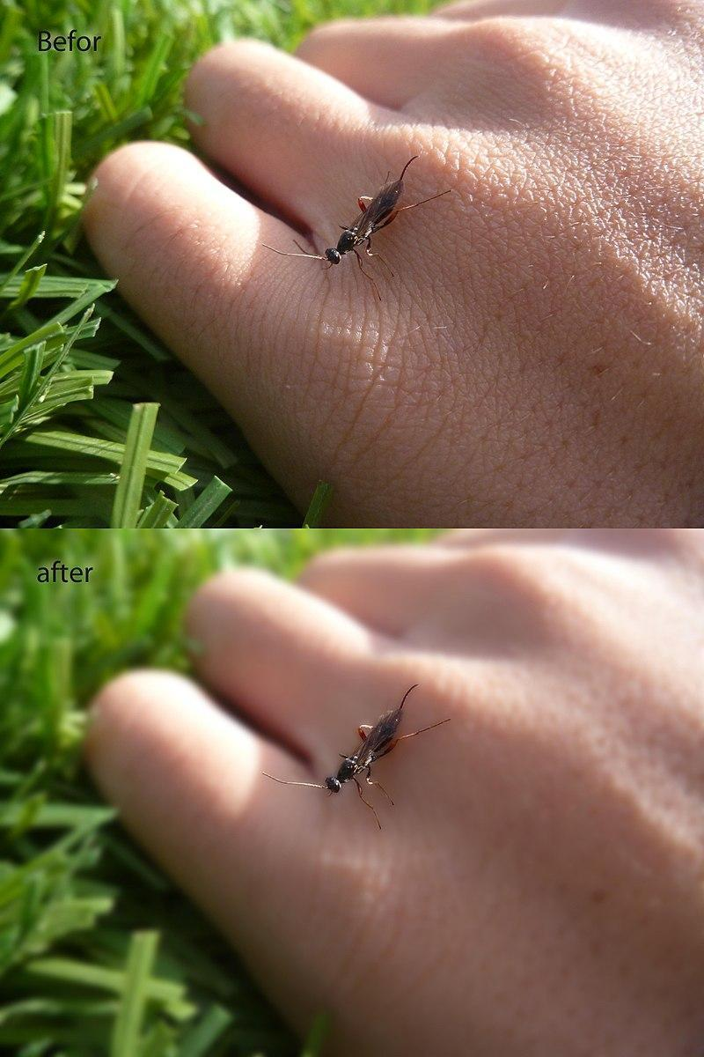

**Image Editors Features**

**5.8 Some of the most used capabilities of the better graphic manipulation programs:**

* + Selection
  + Layers
  + Image Size Alteration
  + Cropping an Image
  + Cutting out Part of an Image from the Background
  + Histogram
  + Noise Reduction
  + Removal of Unwanted Elements
  + Selective Color Change
  + Image Orientation
  + Perspective Control and Distortion
  + Lens Correction
  + Enhancing Images
  + Sharpening and Softening Images
  + Selecting and Merging of Images
  + Slicing of Images
  + Special Effects
  + Stamp Clone Tool
  + Change Color Depth
  + Contrast Change and Brightening
  + Gamma Correction
  + Color Adjustments
  + Dynamic Blending
  + Printing
  + Image Warping
  + Morphing

**Selection:**

* One of the prerequisites for many of the applications is a method of selecting part(s) of an image, thus applying a change selectively without affecting the entire picture.

**Most graphics programs have several means of accomplishing this:**

* **marquee tool** 🡪 for selecting rectangular or other regular polygon-shaped regions
* **lasso tool** 🡪 for freehand selection of a region
* **magic wand tool** 🡪 selects objects or regions in the image defined by proximity of color or luminance
* **vector-based pen tools**

The border of a selected area in an image is animated with the marching ants effect to help the user to distinguish the selection border from the image  
background

**Layers:**

* Are analogous to sheets of transparent acetate (each containing separate elements that make up a combined picture), stacked on top of each other, each capable of being individually positioned, altered and blended with the layers below, without affecting any of the elements on the other layers.
* This is a fundamental workflow for the majority of programs on the market today, and enables maximum flexibility for the user while maintaining non-destructive editing principles and ease of use.

**Layers example**

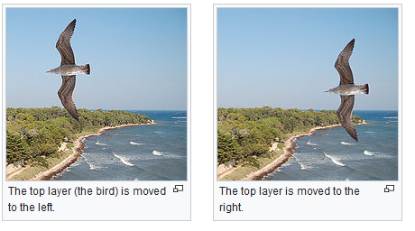

**Image Size Alteration**

* Image editors can resize images in a process often called image scaling, making them larger, or smaller.
* High image resolution cameras can produce large images which are often reduced in size for Internet use.
* Image editor programs use a mathematical process called resampling to calculate new pixel values whose spacing is larger or smaller than the original pixel values.
* Images for Internet use are kept small, say 640 x 480 pixels which would equal 0.3 megapixels.

**Cropping an Image**

* Digital editors are used to crop images.
* Cropping creates a new image by selecting a desired rectangular portion from the image being cropped.
* The unwanted part of the image is discarded.
* Image cropping does not reduce the resolution of the area cropped.
* Best results are obtained when the original image has a high resolution.
* A primary reason for cropping is to improve the image composition in the new image

**Cutting out a Part of an Image from the Background**

* Using a selection tool, the outline of the figure or element in the picture is traced/selected, and then the background is removed.
* Depending on how intricate the "edge" is this may be more or less difficult to do cleanly.
* Hence the use of the "green screen" technique (chroma key) which allows one to easily remove the background.

**Histogram**

* Image editors have provisions to create an image histogram of the image being edited.
* The histogram plots the number of pixels in the image (vertical axis) with a particular brightness value (horizontal axis).
* Algorithms in the digital editor allow the user to visually adjust the brightness value of each pixel and to dynamically display the results as adjustments are made.
* Improvements in picture brightness and contrast can thus be obtained.

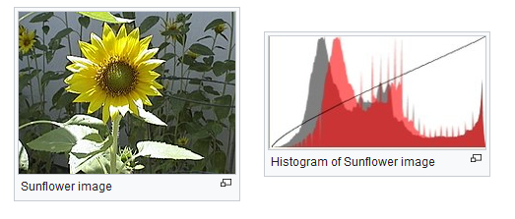

**Noise Reduction**

* Image editors may feature a number of algorithms which can add or remove noise in an image.
* Some JPEG artifacts can be removed; dust and scratches can be removed and an image can be de-speckled.

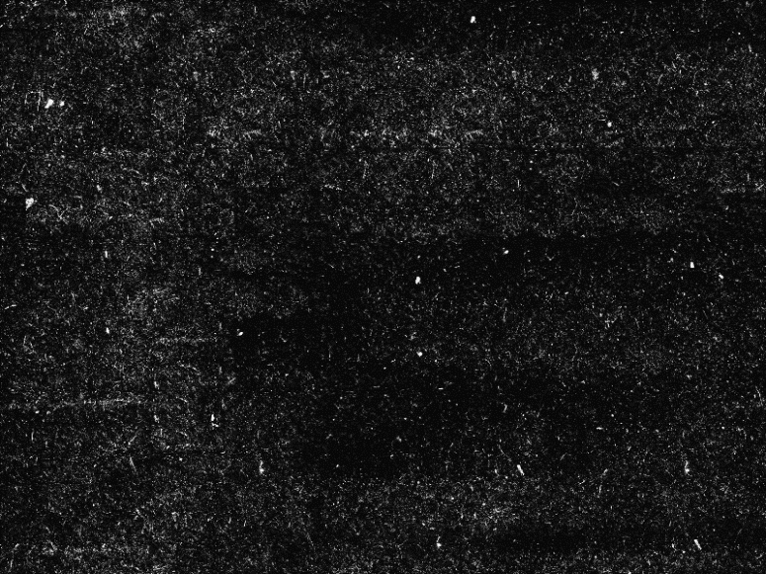

* Noise reduction estimates the state of the scene without the noise and is not a substitute for obtaining a "cleaner" image.
* Excessive noise reduction leads to a loss of detail, and its application is hence subject to a trade-off between the undesirability of the noise itself and that of the reduction artifacts.
* Noise tends to invade images when pictures are taken in low light settings.
* A new picture can be given an "antiqued" effect by adding uniform monochrome noise.



**Selective Color Change**

* Some image editors have color swapping abilities to selectively change the color of specific items in an image, given that the selected items are within a specific color range.

**Image Orientation**

* Image editors are capable of altering an image to be rotated in any direction and to any degree.
* Mirror images can be created and images can be horizontally flipped or vertically flopped.
* A small rotation of several degrees is enough to level the horizon, correct verticality, or both.
* Rotated images usually require cropping afterwards, in order to remove the resulting gaps at the image edges.

**Enhancing Images**

* The process of improving the quality of a digitally stored image by manipulating the image with software.
* It is quite easy, for example, to make an image lighter or darker, or to increase or decrease contrast.
* Advanced photo enhancement software also supports many filters for altering images in different ways.
* Programs specialized for image enhancement are sometimes called image editors.

**Contrast:**

* The separation between the darkest and brightest areas of the image.
* Increase contrast and you increase the separation between dark and bright, making shadows darker and highlights brighter.

**Brightness vs. Contrast**

* Brightness refers to the overall lightness or darkness of the image.
* Increasing the brightness every pixel in the frame gets lighter.
* Contrast is the difference in brightness between objects in the image.
* Increasing the contrast makes light areas lighter and dark areas in the frame become much darker.

**Sharpening and Softening Images:**

* Graphics programs can be used to both sharpen and blur images in a number of ways, such as unsharp masking or deconvolution.
* Blurring 🡺 reduce image noise and reduce detail.

Applying a Gaussian blur to an image is the same as **convolving the image with a Gaussian function.**

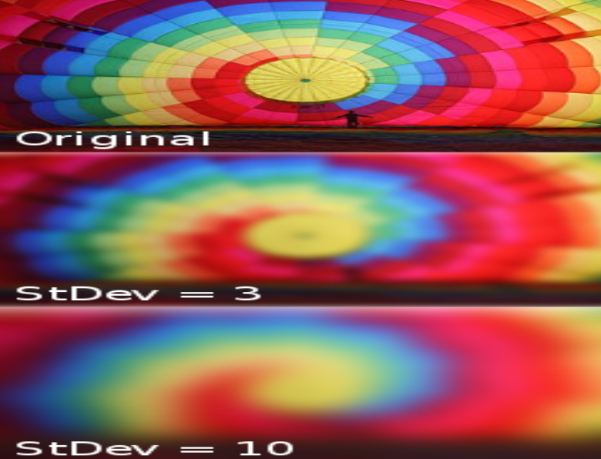

* Portraits appear more pleasing when selectively softened to better make the subject stand out.
* Can be achieved with a camera by **using a large aperture**, or in the image editor by making a **selection and then blurring it**.
* Edge enhancement is a technique used to make images appear sharper, although purists frown on the result as appearing unnatural.
* Another form of image sharpening involves a form of contrast.
* This is done by finding the **average color of the pixels around each pixel** in a specified radius, and **then contrasting that pixel from that average color.**
* This effect makes the **image seem clearer**.
* It is widely used in the **printing and photographic industries**.

**Selecting and Merging of Images:**

* Graphics applications are capable of merging one or more individual images into a single file.
* The orientation and placement of each image can be controlled.
* When selecting a raster image that is not rectangular, it requires separating the edges from the background, also known as silhouetting.
* Clipping may be used to add silhouetted images to vector graphics or page layout files that retain vector data.
* Alpha compositing, allows for soft translucent edges when selecting images.
* There are a number of ways to silhouette an image with soft edges:
* Selecting the image or its background by sampling similar colors
* Selecting the edges by raster tracing
* Converting a clipping path to a raster selection.
* A popular way to create a composite image is to use transparent layers.
* The **background image is used as the bottom layer**, and the image with **parts to be added are placed in a layer above that**.
* **Using an image layer mask**, all but the **parts to be merged are hidden from the layer**, giving **the impression that these parts have been added to the background layer**.
* This preserves all of the pixel data on both layers to more easily enable **future changes in the new merged image.**

**Slicing an Image:**

* Image slicing is a technique for creating a web page (or a component of a web page) visually in Photoshop.
* Parts of images for graphical user interfaces or web pages are easily sliced, labeled and saved separately from whole images
* The parts can be handled individually.
* This allows dynamic swapping via interactivity or animating parts of an image in the final presentation.

**Special Effects:**

* Image editors have a list of special effects that can create unusual results.
* Images may be skewed and distorted.
* Scores of special effects can be applied to an image which include various forms of distortion, artistic effects, geometric transforms and texture effects.

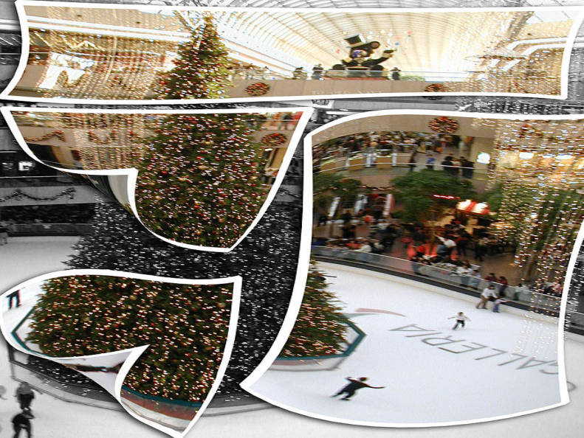

* Using settings in Image editors such as PhotoShop, one can mimic the "pseudo-solarisation" effect, known as the Sabattier-effect

**Stamp Clone Tool**

* The Clone Stamp tool selects and samples an area of the picture and then uses these pixels to paint over any marks.
* The Clone Stamp tool acts like a brush so you can change the size, allowing cloning from just one pixel wide to hundreds.
* You can change the opacity to produce a subtle clone effect.
* In Photoshop this tool is called **Clone Stamp**, but it may also be called **a Rubber Stamp tool**

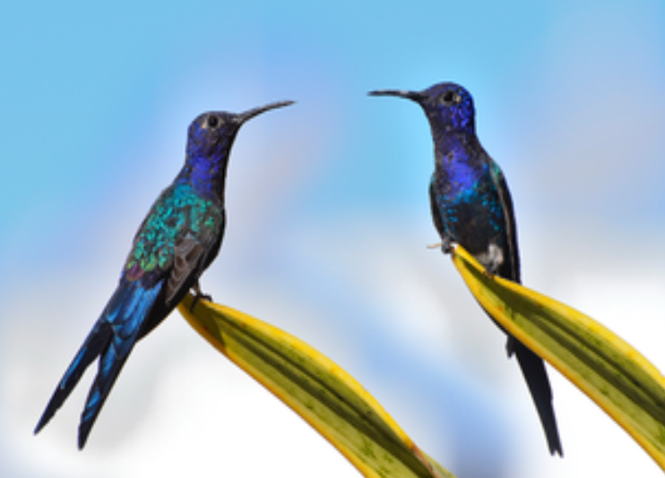

**Change Color Depth**

* It is possible to change the color depth of images.
* Common color depths are 2, 4, 16, 256, 65,536 and 16.7 million colors.
* The JPEG and PNG image formats are capable of storing 16.7 million colors.
* Luminance 🡺 It describes the amount of light that passes through.
* Grayscale images of 8 bits or less can be created 🡺 via conversion and down-sampling from a full-color image.
* Grayscale conversion is useful for reducing file size dramatically when the original photographic was monochrome [aging effects].

**Contrast Change and Brightening**

* Image editors can change the contrast of images and brighten or darken the image.
* Underexposed images can be improved by using this feature.
* More intelligent exposure correction 🡺 only pixels below a particular luminosity threshold are brightened, so brightening underexposed shadows without affecting the rest of the image
* The exact transformation that is applied to each color channel can vary from editor to editor.

**Gamma Correction**

* Changing the images’ brightness and/or contrast is in a non-linear fashion
* Image editors provide an opportunity to manipulate the images’ gamma value.
* Varying the amount of gamma correction changes not only the brightness, but also the ratios of red to green to blue.
* Gamma correction 🡺 useful for bringing details that would be hard to see on computer monitors.
* In some image editing software this is called "curves".
* The curves tool does more than simple gamma correction, since one can construct complex curves with multiple inflection points.
* A lot of games often include a gamma correction feature when you first start playing the game.
* Gamma correction function 🡺 is a function that maps luminance levels to achieve the non-linear luminance effect of display devices.
* Is Gamma a Brightness? NO

**Color Adjustments**

* Colors can be faded in and out, and tones can be changed using curves or other tools.
* The color balance can be improved, which is important if the picture was shot indoors with daylight film, or shot on a camera with the white balance incorrectly set.
* More complicated procedures such as the mixing of color channels are possible using more advanced graphics editors.
* The red-eye effect can also be eliminated at this stage.

**Dynamic Blending**

* Dynamic Blending images serve to display a consolidated moment.
* This means that **while the final image may be a blend of a span of time**, it visually **appears to represent a single instant.**

**Printing**

* Controlling the print size and quality of digital images requires an understanding of the pixels-per-inch (ppi) variable that is stored in the image file.
* The image editor allows the user to manipulate both pixel dimensions and the size of the image printed.
* Pixels per inch of the image, pixel per inch of the computer monitor, and dots per inch on the printed document are related, but in use are very different.
* 1600 x 1200 image with a resolution of 200 ppi will produce a printed image of 8 x 6 inches.
* All printed images contain the same data but the pixels are closer together on the smaller prints.
* The quality of the image will depend on the capability of the printer.
* Control printed image by changing pixels-per-inch

**Image Warping**

* Image warping 🡺is the process of digitally manipulating an image such that any shapes portrayed in the image have been significantly distorted.
* Warping may be used for correcting image distortion as well as for creative purposes.
* The same techniques are equally applicable to video
* Pure warping means that points are mapped to points without changing the colors.
* This can be based mathematically on any function from the plane to the plane.
* If the function is injective, the original can be reconstructed.
* If the function is a bijection, any image can be inversely transformed.
* Images can be partitioned into polygons and each polygon distorted.
* Images can be distorted using morphing.
* There are at least two ways to generate an image using whatever chosen methods to distort.
* **forward-mapping** 🡺 a given mapping from sources to images is directly applied
* **reverse-mapping** 🡺 for a given mapping from sources to images, the source is found from the image
* To estimate what kind of warping, one can use optical flow estimation techniques.

**Morphing**

* Morphing 🡺 a special effect in motion pictures and animations that changes one image or shape into another through a seamless transition.
* Traditionally such a depiction would be achieved through cross-fading techniques.
* This has been replaced by computer software to create **more realistic transitions.**

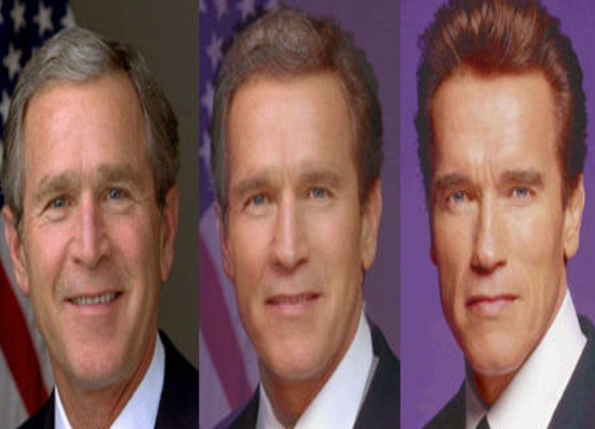

**Perspective Control and Distortion**

* Some image editors allow the user to distort (or "transform") the shape of an image.
* It is the preferred method of correcting the perspective distortion which results from photographs being taken at an oblique angle to a rectilinear subject.
* Care is needed while performing this task, as the image is reprocessed using interpolation of adjacent pixels 🡺 reduce overall image definition.
* The effect mimics the use of a **perspective control lens** 🡺 which **achieves a similar correction in-camera without loss of definition.**

**Lens Correction**

* Photo manipulation packages have functions to correct images for various lens distortions including pincushion, fisheye and barrel distortions.
* The corrections are in most cases subtle, but can improve the appearance of some photographs.
* Barrel Distortion 🡺 a type of defect in images in which vertical or horizontal straight lines appear as convex curves.
* Pincushion Distortion 🡺 is the exact opposite of barrel distortion ( straight lines are curved outwards from the center).
* Commonly seen on telephoto lenses
* It occurs due **to image magnification increasing** towards the edges of **the frame from the optical axis.**

